**ADF 11g Release Notes For EXT0117**

Expenditure Type Transfer Extension

***Version (1.0)***

***30-Mar-2015***

Document Information

| Criteria | Details |
| --- | --- |
| Document Title: | Expenditure Type Transfer Extension |
| Document Owner: |  |
| Document Author: | Sreekanth Madamanchi |
| Version: | 1.0 |
| Issue date: | 01-Dec-2014 |

Version Control

| Version | Date | Reason and Changes Made | Author(s) |
| --- | --- | --- | --- |
| 1.0 | 01-Dec-2014 | Initial Version |  |
|  |  |  |  |

Table of Contents

Document Information 2

Version Control 2

Table of Contents 3

1. **Release Notes** 3

**1.1** **Introduction** 4

**1.2** **Items Included** 4

**1.3** **Prerequisites** 4

**1.4** **Known Issues** 4

**1.5** **Summary of Packages** 4

**1.5.1** **ADFLib Jar file required, which are available in the deploy folder of the respective component.** 5

**1.5.2** **Resource Names Required** 5

**1.5.3** **Entitlement Names Required** 5

**1.6** **Deployment Steps** 5

**1.6.1** **Database Deployment steps** 5

**1.6.2** **ADF Deployment Step** 6

**1.6.3** **Connection Creations steps** 6

**1.6.4** **Mar Deployment Steps** 10

**1.7** **Component Test Results** 14

**1.8** **System Test Results** 14

**1.9** **Document Reference** 14

**1.10** **Assumptions** 14

**1.11** **Release Notes Summary** 14

2. Functional Description 15

3. Component Testing Summary Overview 15

4. Open Points 15

# 

## **Release Notes**

## **Introduction**

This document talk about the Transfer Expenditure Type Extension, this extension enables a link in Expenditure Item search result table Actions-> costing-> Transfer Expenditure Type.

## **Items Included**

The following items have been included in this release:

|  |  |  |
| --- | --- | --- |
| 1. | Transfer Expenditure Type Extension | This Extension is the new in the R2, this extension allow user to transfer Expenditure Item from one Expenditure Type to another Expenditure Type. |
|  |  |  |
|  |  |  |

## **Prerequisites**

The following prerequisites are required for this release.

| Number | Description |
| --- | --- |
| **1.** | Security team should know the Roles having access on this application. |
| **2.** | Security team should list down all the Application roles which need access on this form. |
| **3.** | User should have admin access on APM, and admin server access on FA servers, to place files over the file system of FA servers. |
| **4.** | Administrator should have the passwords to do the DDL activity on fusion, fusion_custom and fusion_runtime. |
| **5.** | DB tables should be create in custom schema |
|  |  |

## **Known Issues**

The following known issues have been identified in this release:

|  |  |  |  |
| --- | --- | --- | --- |
| **1** |  |  |  |

## 

## **Summary of Packages**

## **ADFLib Jar file required, which are available in the deploy folder of the respective component.**

|  |  |
| --- | --- |
| 1. | XXADFLibE0117ExpenditureTypeTransferBundle.jar |
| 2. | XXADFLibE0117ExpenditureTypeTransferCustUI.jar |
| 3. | XXADFLibE0117ExpenditureTypeTransferModel.jar |

## **Resource Names Required**

The following resources need to be created in the APM which require proper permissions,

| Resource Type | Display Name | Resource Name. |
| --- | --- | --- |
| Taskflow Type | XX PRJ E0117 XXExpenditureTypeTransferFlow | /WEB-INF/xx/oracle/apps/xxprojects/costing/transactions/ui/flow/XXExpenditureTypeTransferFlow.xml#XXExpenditureTypeTransferFlow |
|  |  |  |

## **Entitlement Names Required**

|  |  |  |
| --- | --- | --- |
| Entitlement Display Name | Entitlement Name | Description |
| XXPRJ E0117 Expenditure Type Transfer | XXPRJ_E0117_EXPENDITURE_TYPE_TRANSFER | Entitlement for the Custom Expenditure Type Transfer.. |

Please add the above resources to this entitlement with view grant, and then send it to functional team, they will add the roles to the entitlements.

## **Deployment Steps**

## **Database Deployment steps**

1. Run the database script from the db folder.
   1. <R2 SVN trunk>\projects\EXT0117.0\db

XXPJC_E0117_EXPITM_TRANS_INPT_DDL.sql

* 1. It will create the table in custom schema, please check by running the following statements.

SELECT * FROM XX_FUSION_CUSTOM. XXPJC_E0117_EXPITM_TRANS_INPT;

* 1. Run the following script for providing grants for the table

XXPJC_E0117_EXPITM_TRANS_INPT_GRT.sql

* 1. Run the following script to create fnd_messages

XXPJC_E0117_FND_MESSAGES.sql

* 1. Create the package spec and body by running the following scripts

XXPJC_E0117_EXPTYPE_IMPORT_PKG.pks

XXPJC_E0117_EXPTYPE_IMPORT_PKG.pkb

* 1. Run the following script for providing grants for the procedure

XXPJC_E0117_EXPTYPE_IMPORT_PKG_GRT.sql

* 1. Create the sequence XXPPM_E0117_TRANS_ID_S by running the following scripts

XXPJC_E0117_TRANS_ID_S.sql

XXPJC_E0117_TRANS_ID_S_GRT.sql

* 1. **ESS Job MAR file deployment**

1. Copy mar "XXPJCEXT0117CreateESSJob.mar" to your local drive(secured path) for import from <R2 SVN trunk>\projects\EXT0117.0\db
2. Log into Financial Enterprise Manager of the target system environment
3. Navigate to Oracle Fusion Financial > Fusion Applications > FinancialsEssApp
4. Right click on FinancialsEssApp (ess_server1) and click on MDS Configuration
5. Under the Import section on the right side of the page browse for the MAR file (Import metadata documents from an archive on the machine where this web browser is running)
6. Select **XXPJCEXT0117CreateESSJob.mar** and Click on IMPORT button, so it will import the ess job definition metadata

## **ADF Deployment Step**

Place the deployed jar at the following locations by taking from <R2 SVN trunk>\projects\EXT0117.0\adf

Place the jar in the EarProjectsFinancials ear in the directories given below

|  | Jar Name | Path to be placed |
| --- | --- | --- |
| 1. | XXADFLibE0117ExpenditureTypeTransferBundle.jar | EarProjectsFinancials.ear\APP-INF\lib |
| 2. | XXADFLibE0117ExpenditureTypeTransferCustUI.jar | EarProjectsFinancials.ear\EarProjectsFinancials.war\WEB-INF\lib |
| 3. | XXADFLibE0117ExpenditureTypeTransferModel.jar | EarProjectsFinancials.ear\APP-INF\lib |
| 4. | XXAdfPJCEXT0117ESSModel.jar | EarProjectsFinancials.ear\APP-INF\lib |

## 

## **Connection Creations steps**

1. Open the JDeveloper and then Create Application Server Connection. Choose application sever Navigator

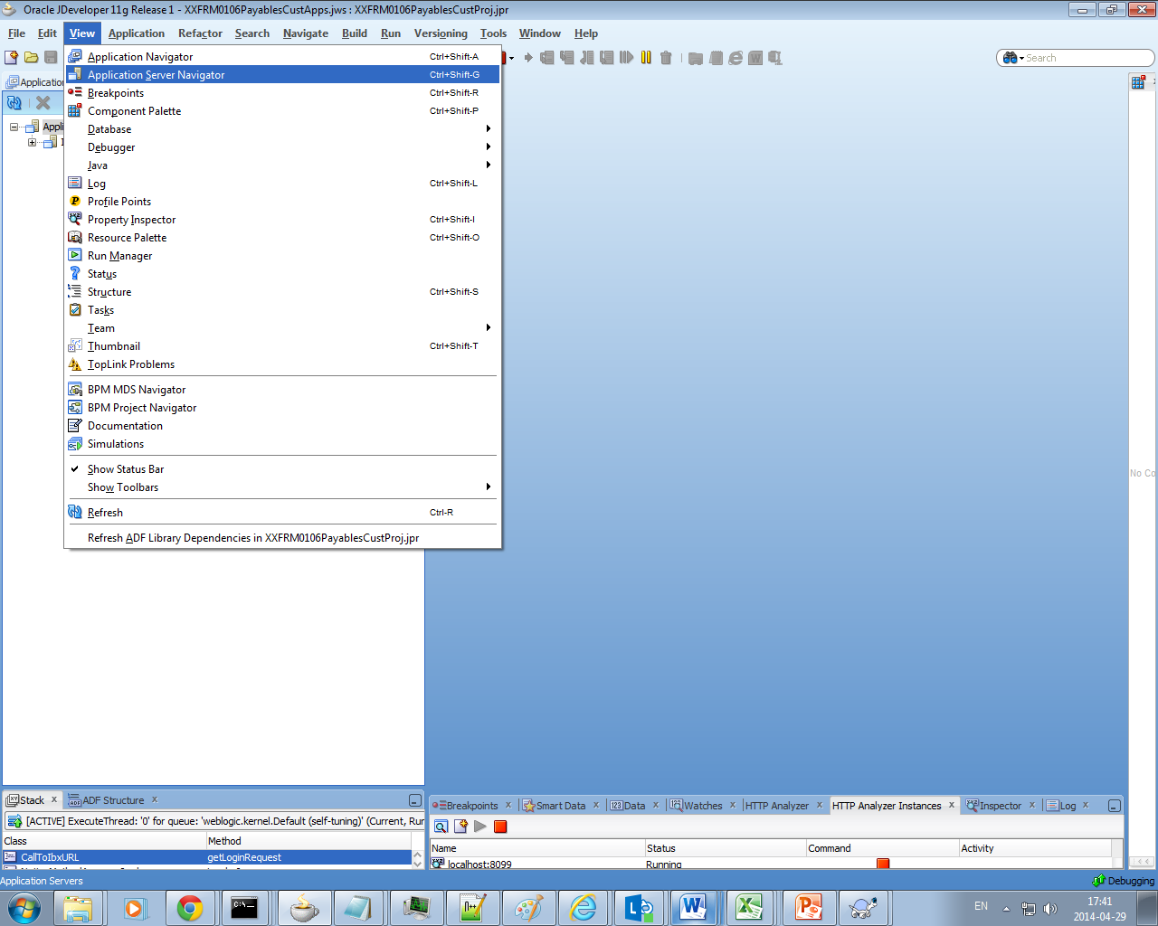

1. Now choose a new application server. It will open a new wizard

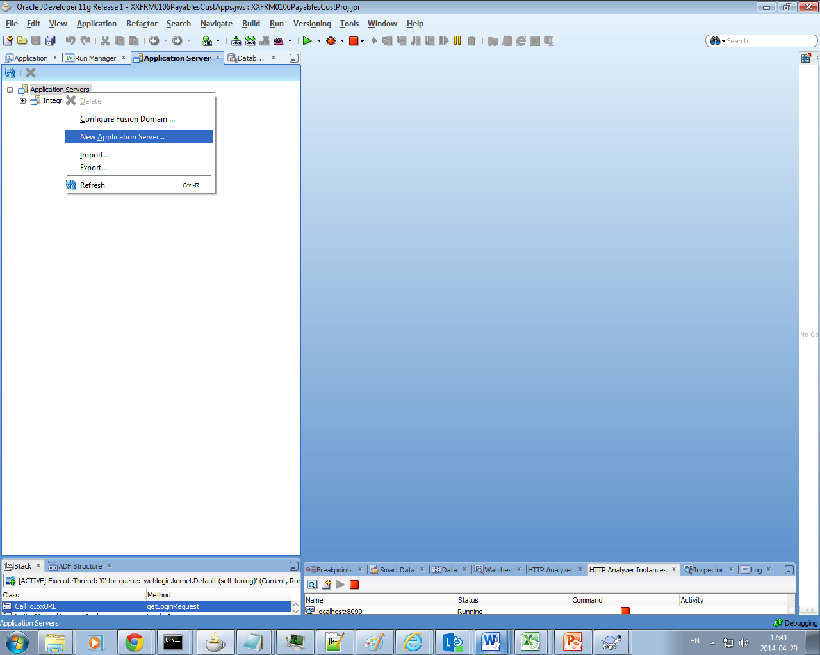

1. Choose Standalone Server

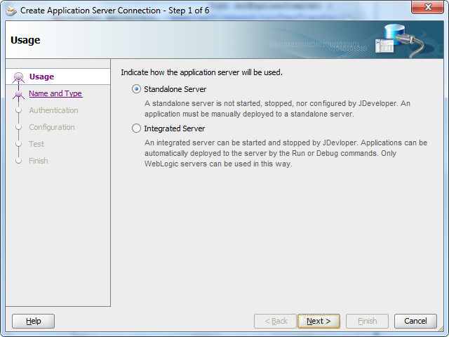

1. Provide a Domain name which is created in WebLogic console (ProjectsDomain)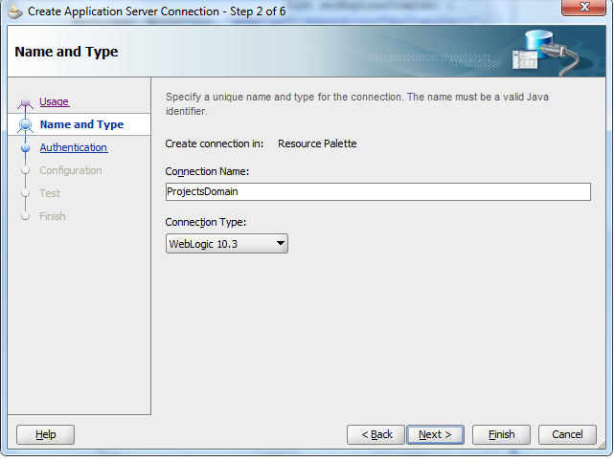

Click Next.

Enter details :

Username : <username of Weblogic Server Financial Domain>

Password: <password of Weblogic Server>

And Click Next.

1. Give the detail for the Project Financial server.

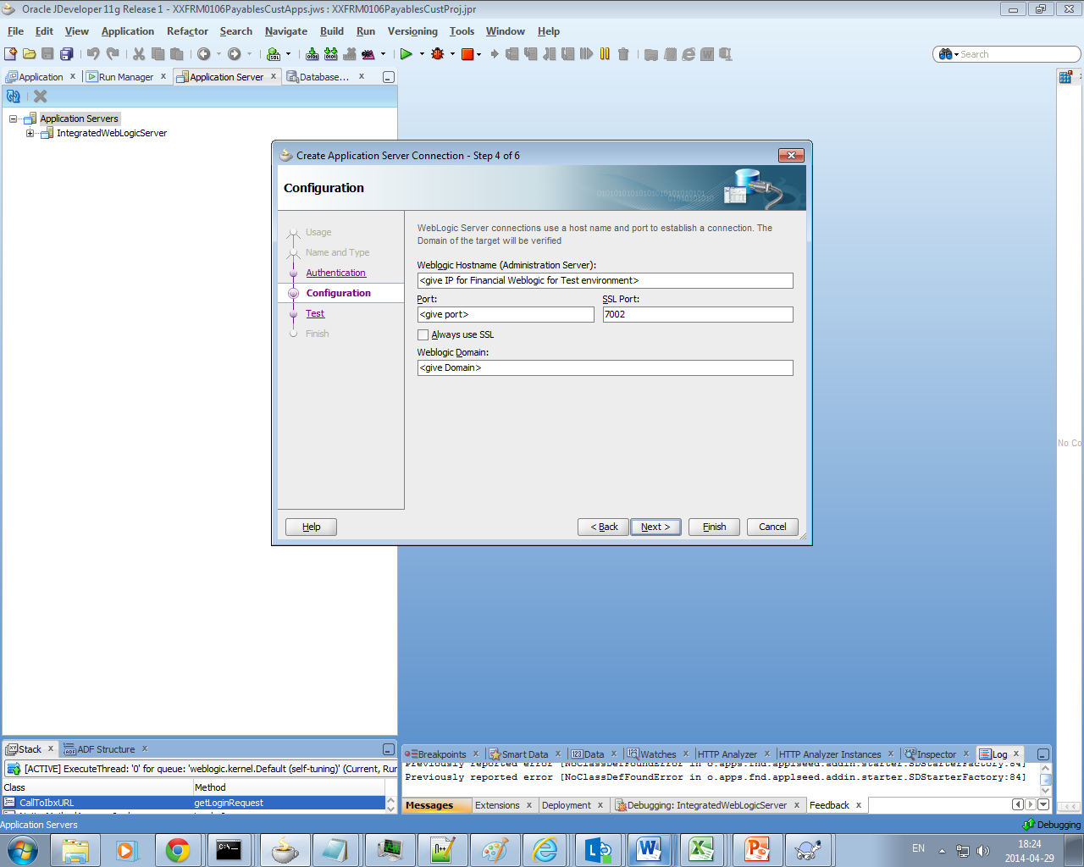

1. If there is any issue in the connection then please make sure you give correct host and port for Project Financial WebLogic Server being used for UAT.

Now Open **hosts file** on path : C:\Windows\System32\drivers\etc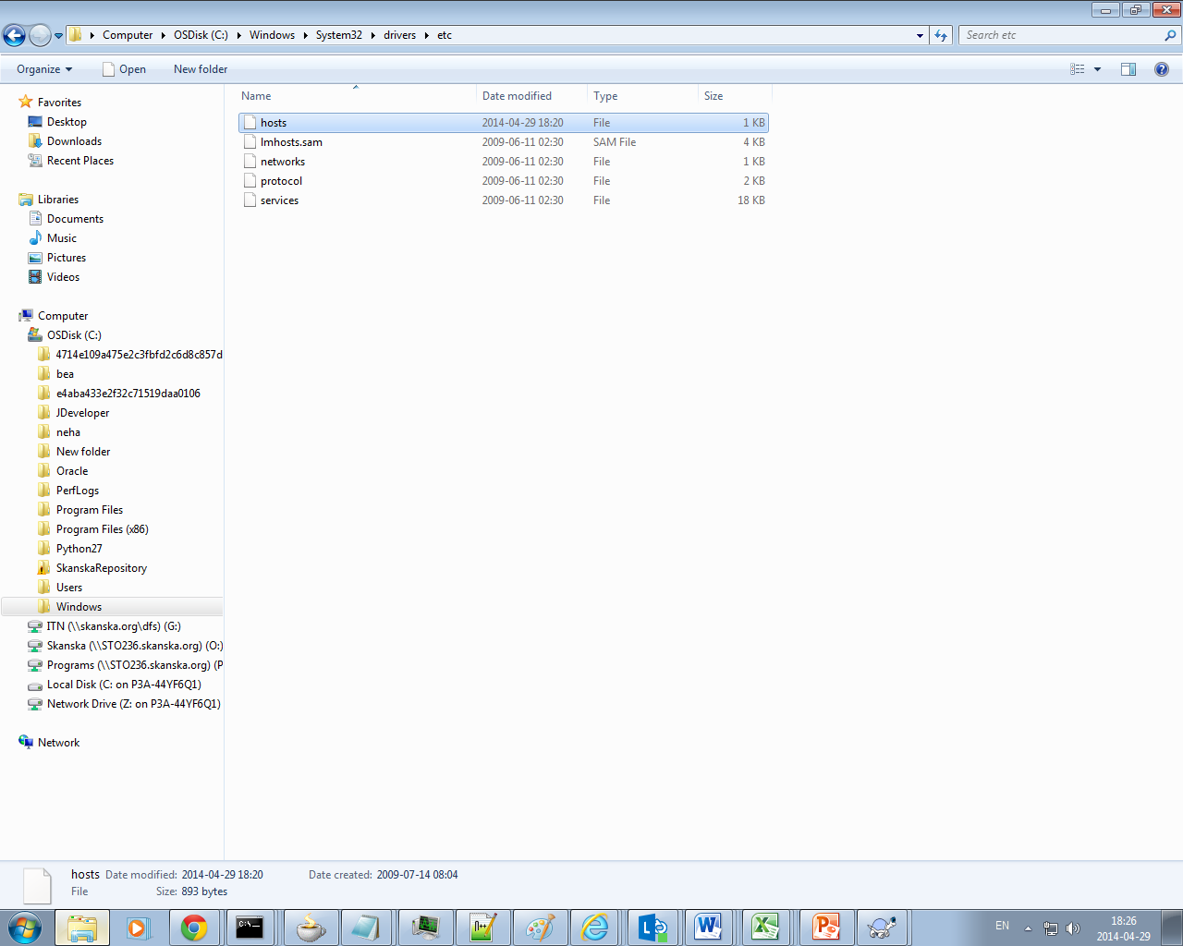

Change security settings to open it if you get Access denied message.

Add one line to the End of file as shown below. Enter the IP and Host name for weblogic Server Project Financial Domain.

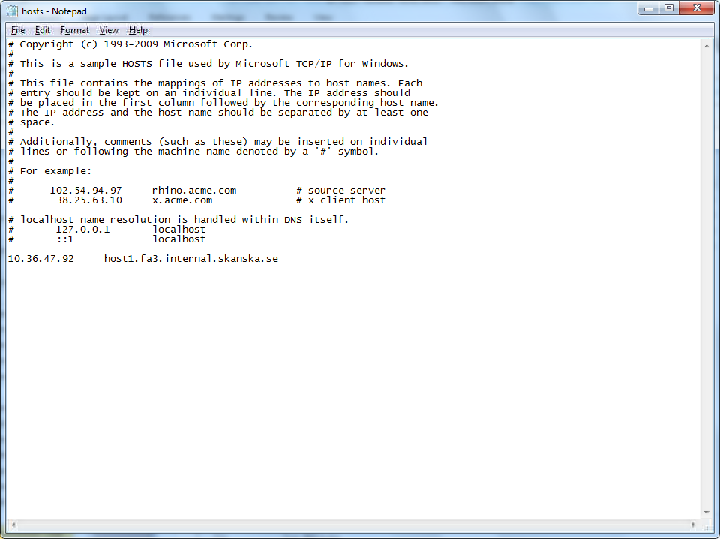

Now Go back to Jdeveloper and click next. Perform Test Connection.

All tests should be successful.

1. Now connection should be

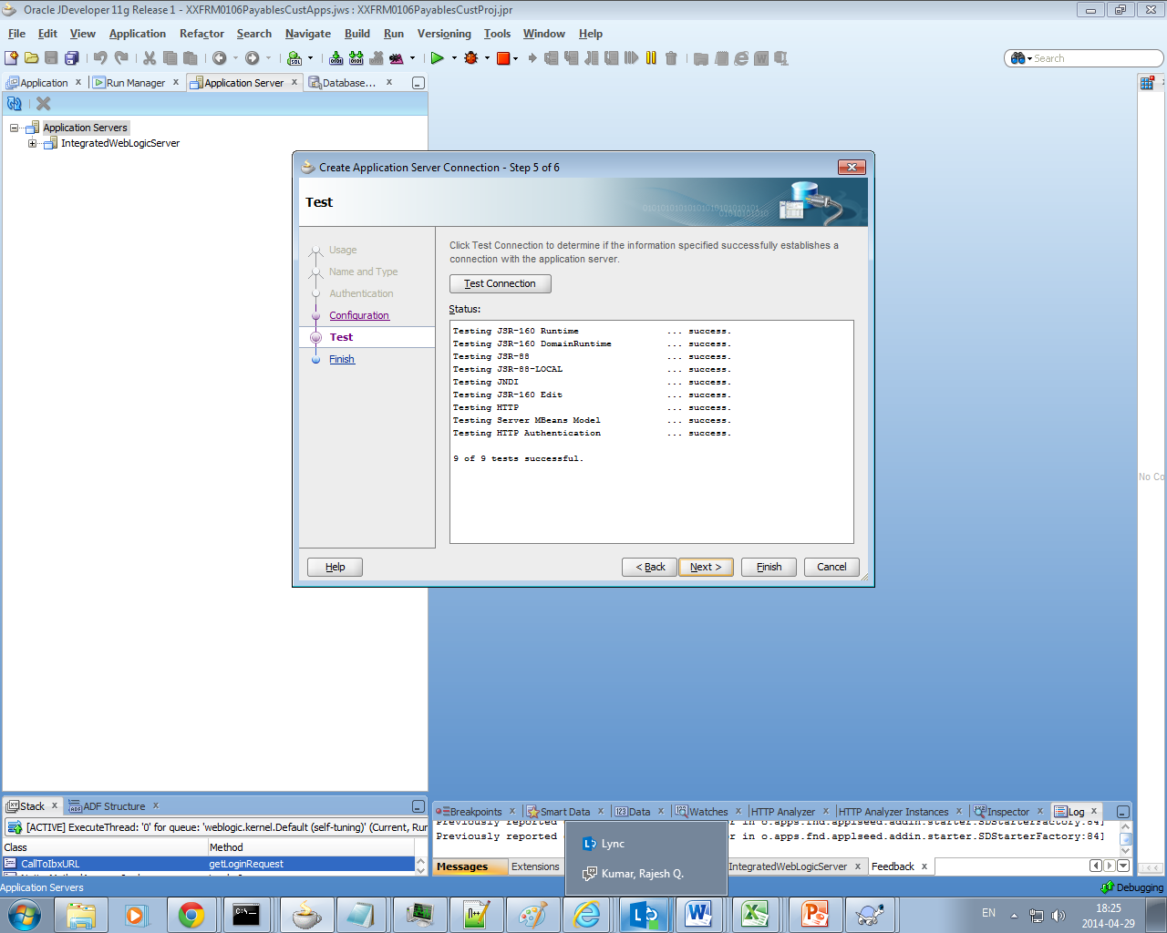

Finish the wizard.

## **Mar Deployment Steps**

1. Open the jws project XXEXT0117ExpenditureTypeTransferCustApp.jws in the jdeveloper.
2. Now application is open, choose the application and then right click and choose deploy and choose XXMAR

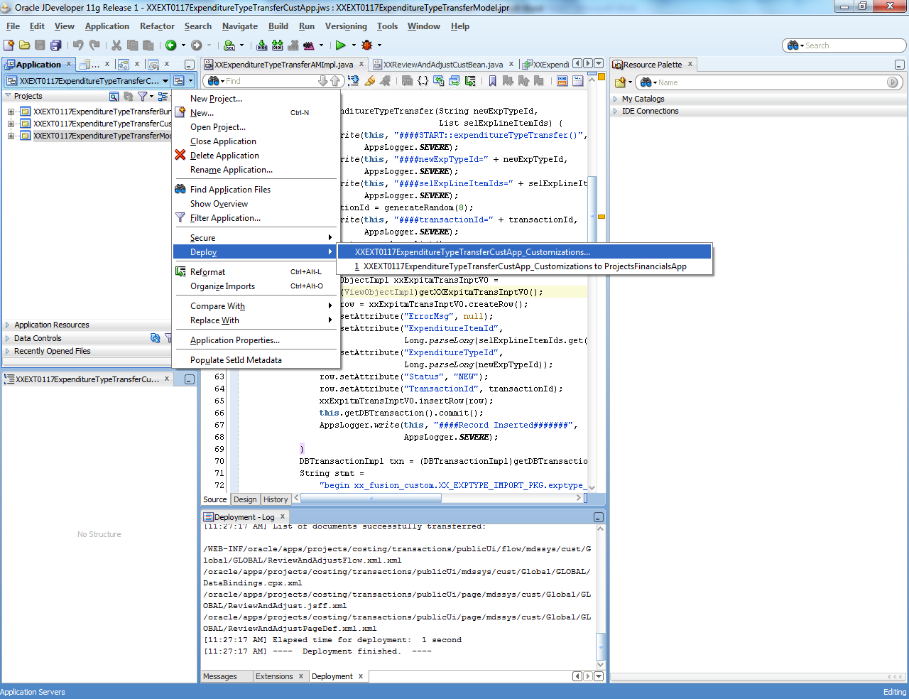

1. Now a wizard will open choose to Export to Deployed Application.

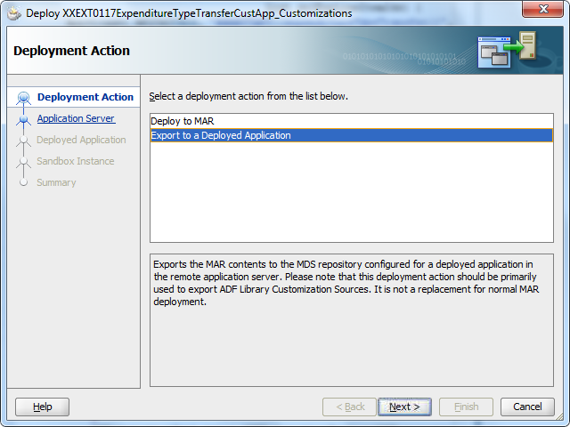

1. Now choose newly created connection, and say next

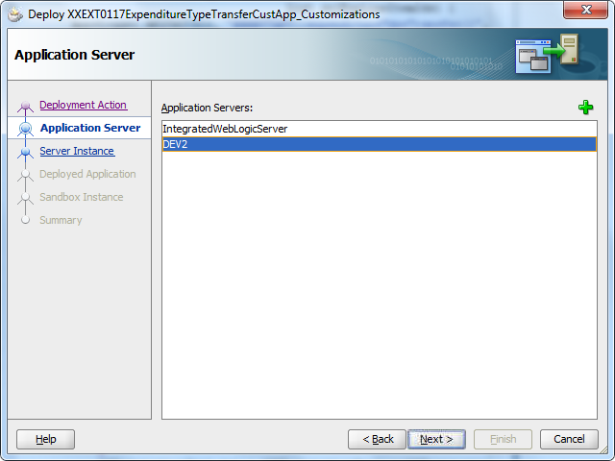

1. Now choose the ProjectsFinancialsServer instance and click next

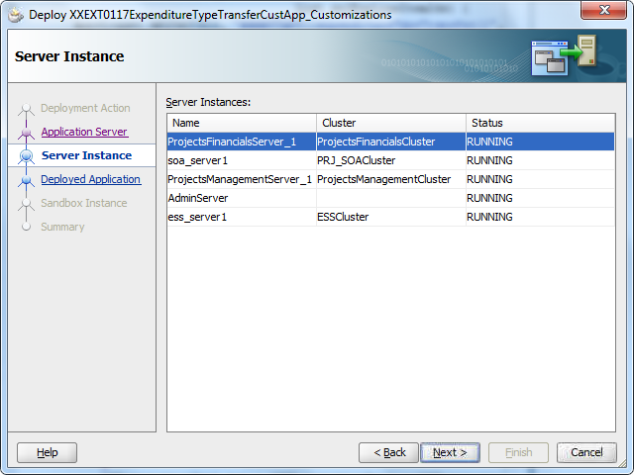

1. Now choose the ProjectFinancialsApps and then choose next

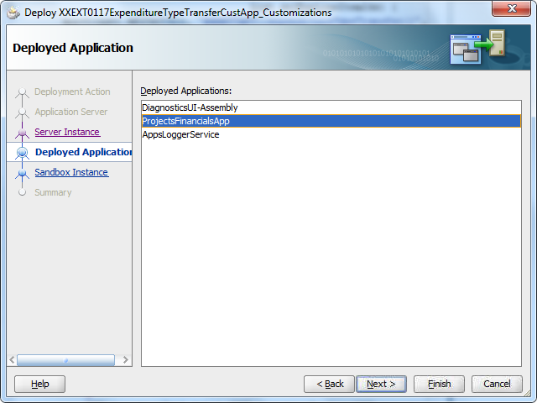

1. Now put the value as default and then deployed and click on finish.

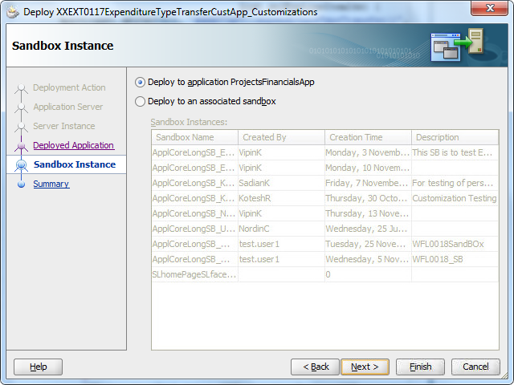

## **Component Test Results**

The below table provides the results of the component testing performed.

1. **Use Case**

| Test Case | Results |  |
| --- | --- | --- |
| 1. Log out from the application and login with a user having access to remittance page. | User should be able to access and see the page. |  |
|  |  |  |

## **System Test Results**

| Application | Functionality/ Business Concept | Results | Impact/Risk/Comments |
| --- | --- | --- | --- |
|  |  |  |  |
|  |  |  |  |

## **Document Reference**

| Document Name | Document Version | Document |
| --- | --- | --- |
|  |  |  |
|  |  |  |

## **Assumptions**

Following assumptions has been made with respect to these services:

|  |  |
| --- | --- |
| **1.** | Security team should be enabled with all the entitlement and there usages. |
| **2.** | Security team has to place the plan for the auto - provisioning. |
| **3.** | Roles and entitlement should be identified to give access to above resources. |

## **Release Notes Summary**

|  |  |
| --- | --- |
| **Release** |  |
| **Drop** |  |
| **Name of Product / Component** |  |
| **Version Number** |  |
| **Product Overview** |  |
| **Date of the release** |  |
| **System requirements** |  |

|  |
| --- |
| **Additions** |
| * N/A |
| **Removals** |
| * N/A |
| **Changes** |
| * N/A |
| **Fixes** |
| * N/A |

# **Functional Description**

# **Component Testing Summary Overview**

# **Open Points**

Following are the open points with the release:

| # | Interface Name | Issue Name | Comments |
| --- | --- | --- | --- |
|  |  |  |  |